Story board for the game

The look

Fantasy = “welcome to Timberdale” sign upfront with happy chubby villages in the background

Peace = Happy chubby villagers sharing apple pie with a nice village barbeque

Until = Until one day

Wizard = the wizard comes in and terrorizes the land, people are running away

And a close up shows the crazy wizard, but behind him in the background is the evil witch hiding in a cloud with puppeteer strings connected to what looks like the same amulet around the wizard’s neck.

Monsters = The wizard starts to raise monsters from the ground, and they start to destroy and chase villagers.

Suffering = The land is destroyed, people are in despair, buildings are in ruins, things are on fire

Despair = the hero hides behind a tree far from the village, clutching her prized possessions. One of them is a picture of the wizard, her secret love. She sees the evil witch and she realizes now what she has to do.

Hero = the hero, grabs her bow and with a face of courage and determination, she sets off to do what is right and save him!

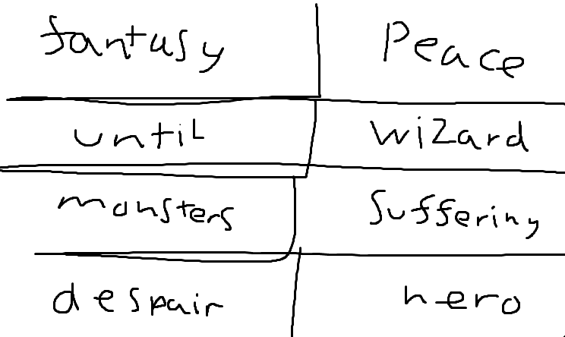

The story

In the land of… “Timberdale?”  
Folks lived simple lives and could blissfully lay in the sun, without a worry in their minds. It was peaceful and quiet in “Timberdale?” and there was always plenty of apple pie to go around.  
  
Until one day, the Wizard in the deep forest caused havoc in the land. He was usually a mellow guy, but something was off. He cackled when he laughed, his eyes were in a trance, and maliciously used his magic to terrorize the peaceful folk in the land.

He was never like this; he was a kind wizard attracted to nature. As powerful as his magic was, he never used it for its violence, only to care for nature. So, what happened?

Well, he had fallen in love with the evil witch you see. The one casted away from the land for using dark magic and causing chaos and chicken fatalities. No apple pie for her so she left the land to someday comeback for her revenge. And revenge was now!   
  
The witch gave the wizard a demonic amulet, that takes over his body to use him and his magic to terrorize the village streets. With her dark magic combined she uses him to summon monsters from the ground, turning them into evil minions to kill everything and everyone.

The land is in ruins, buildings and the villages destroyed

The hero, who is also in love with the wizard but has always been shy to say so, mounds up the courage and strength to get through. She sees the witch controlling the wizard and she knows, that what she must do is save him!